Pythagoras Codebreaker
A | B | C | D | E | F | G | H | I | J | K | L | M
$$6.9$$ | $$5.8$$ | $$6.3$$ | $$23.4$$ | $$8.1$$ | $$14.1$$ | $$9.5$$ | $$4.9$$ | $$16.9$$ | $$18.3$$ | $$18$$ | $$5.7$$ | $$26.4$$
N | O | P | Q | R | S | T | U | V | W | X | Y | Z
$$27$$ | $$36.1$$ | $$4.3$$ | $$7.2$$ | $$9.2$$ | $$22.4$$ | $$23$$ | $$3.7$$ | $$3.6$$ | $$21.3$$ | $$22.9$$ | $$17$$ | $$32$$

Answer the questions below (all answers are rounded to 1 decimal place), link your answers to the table above to reveal what I felt about the German sausage joke:
Calculate the missing length:  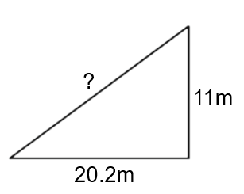 | Calculate the missing length:  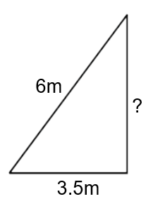 | Calculate the missing length:  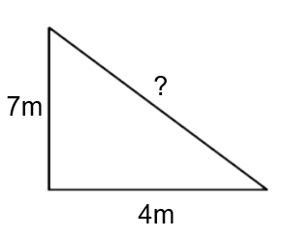 | Calculate the missing length:  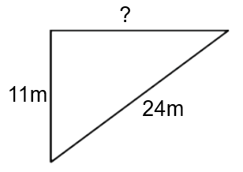
A 4 metre long ladder is leaning against a wall. The base of the ladder is 1.5 metres from the base of the wall. How high up the wall is the top of the ladder? | I travel 7km North then 6km West. How far am I from my start point? | The string attached to my kite is 30m long and the kite is immediately above a friend of mine who is 20m away from me. How high is my kite? | A 50m zip wire is attached to them top of a tower and to the ground 44.4m from the base of the tower. How tall is the tower?

